Cornel West Biography
Cornel West is a prominent and provocative democratic intellectual. He is a Professor of Philosophy and Christian Practice at Union Theological Seminary and Professor Emeritus at Princeton University. He has also taught at Yale, Harvard, and the University of Paris. Cornel West graduated Magna Cum Laude from Harvard in three years and obtained his M.A. and Ph.D. in Philosophy in Princeton. He has written 20 books and edited 13.
He made his film debut in the Matrix-and was the commentator (with Ken Wilbur) on the official trilogy release in 2004. He also appeared in over 25 documentaries and films including Examined Life, Call & Response, Sidewalk and Stand.
In short, Cornel West has a passion to communicate to vast variety of publics in order to keep alive the legacy of Martin Luther King, Jr.-a legacy of telling the truth and bearing witness to love and justice.
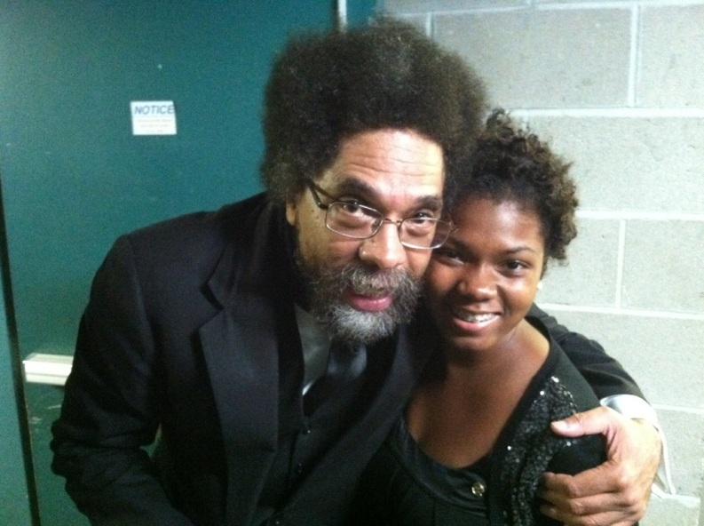
Caption: NSBE Publications Chair: CleAnn Davis with Dr. Cornel West

Clarkson University Spectrum Student Organization

